MU/Stand
042210
Estimated Acreage:

Owner’s Name
Plan Author (if not owner)

Stand Analysis Form

A “healthy forest” must be defined by the natural history of the area and the growth characteristics of the tree species that currently occupy the site. In general, a healthy forest has a majority of trees that are vigorous and resistant to uncharacteristic insect and disease outbreaks and has the ability to sustain itself as a forest through tree survival or tree regeneration when affected by wildfire.
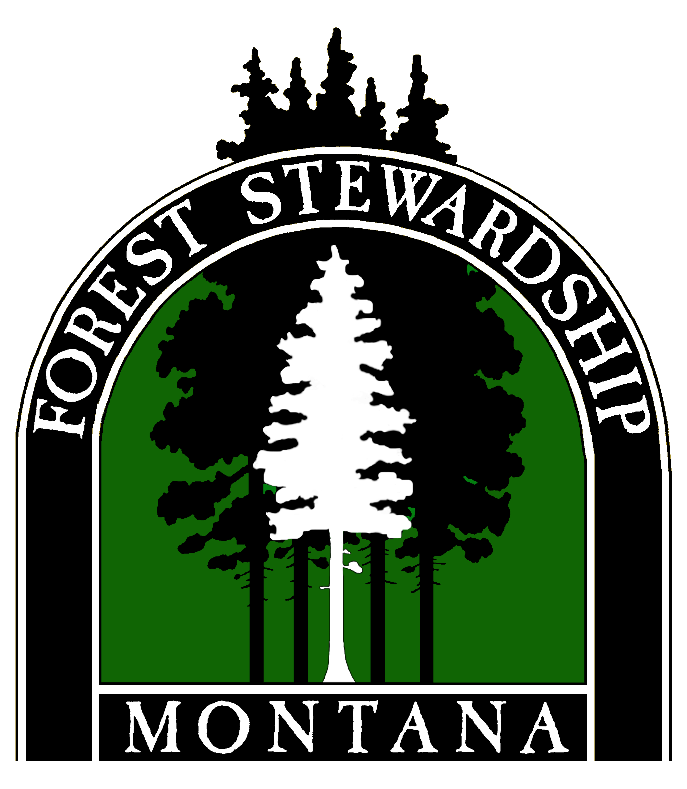
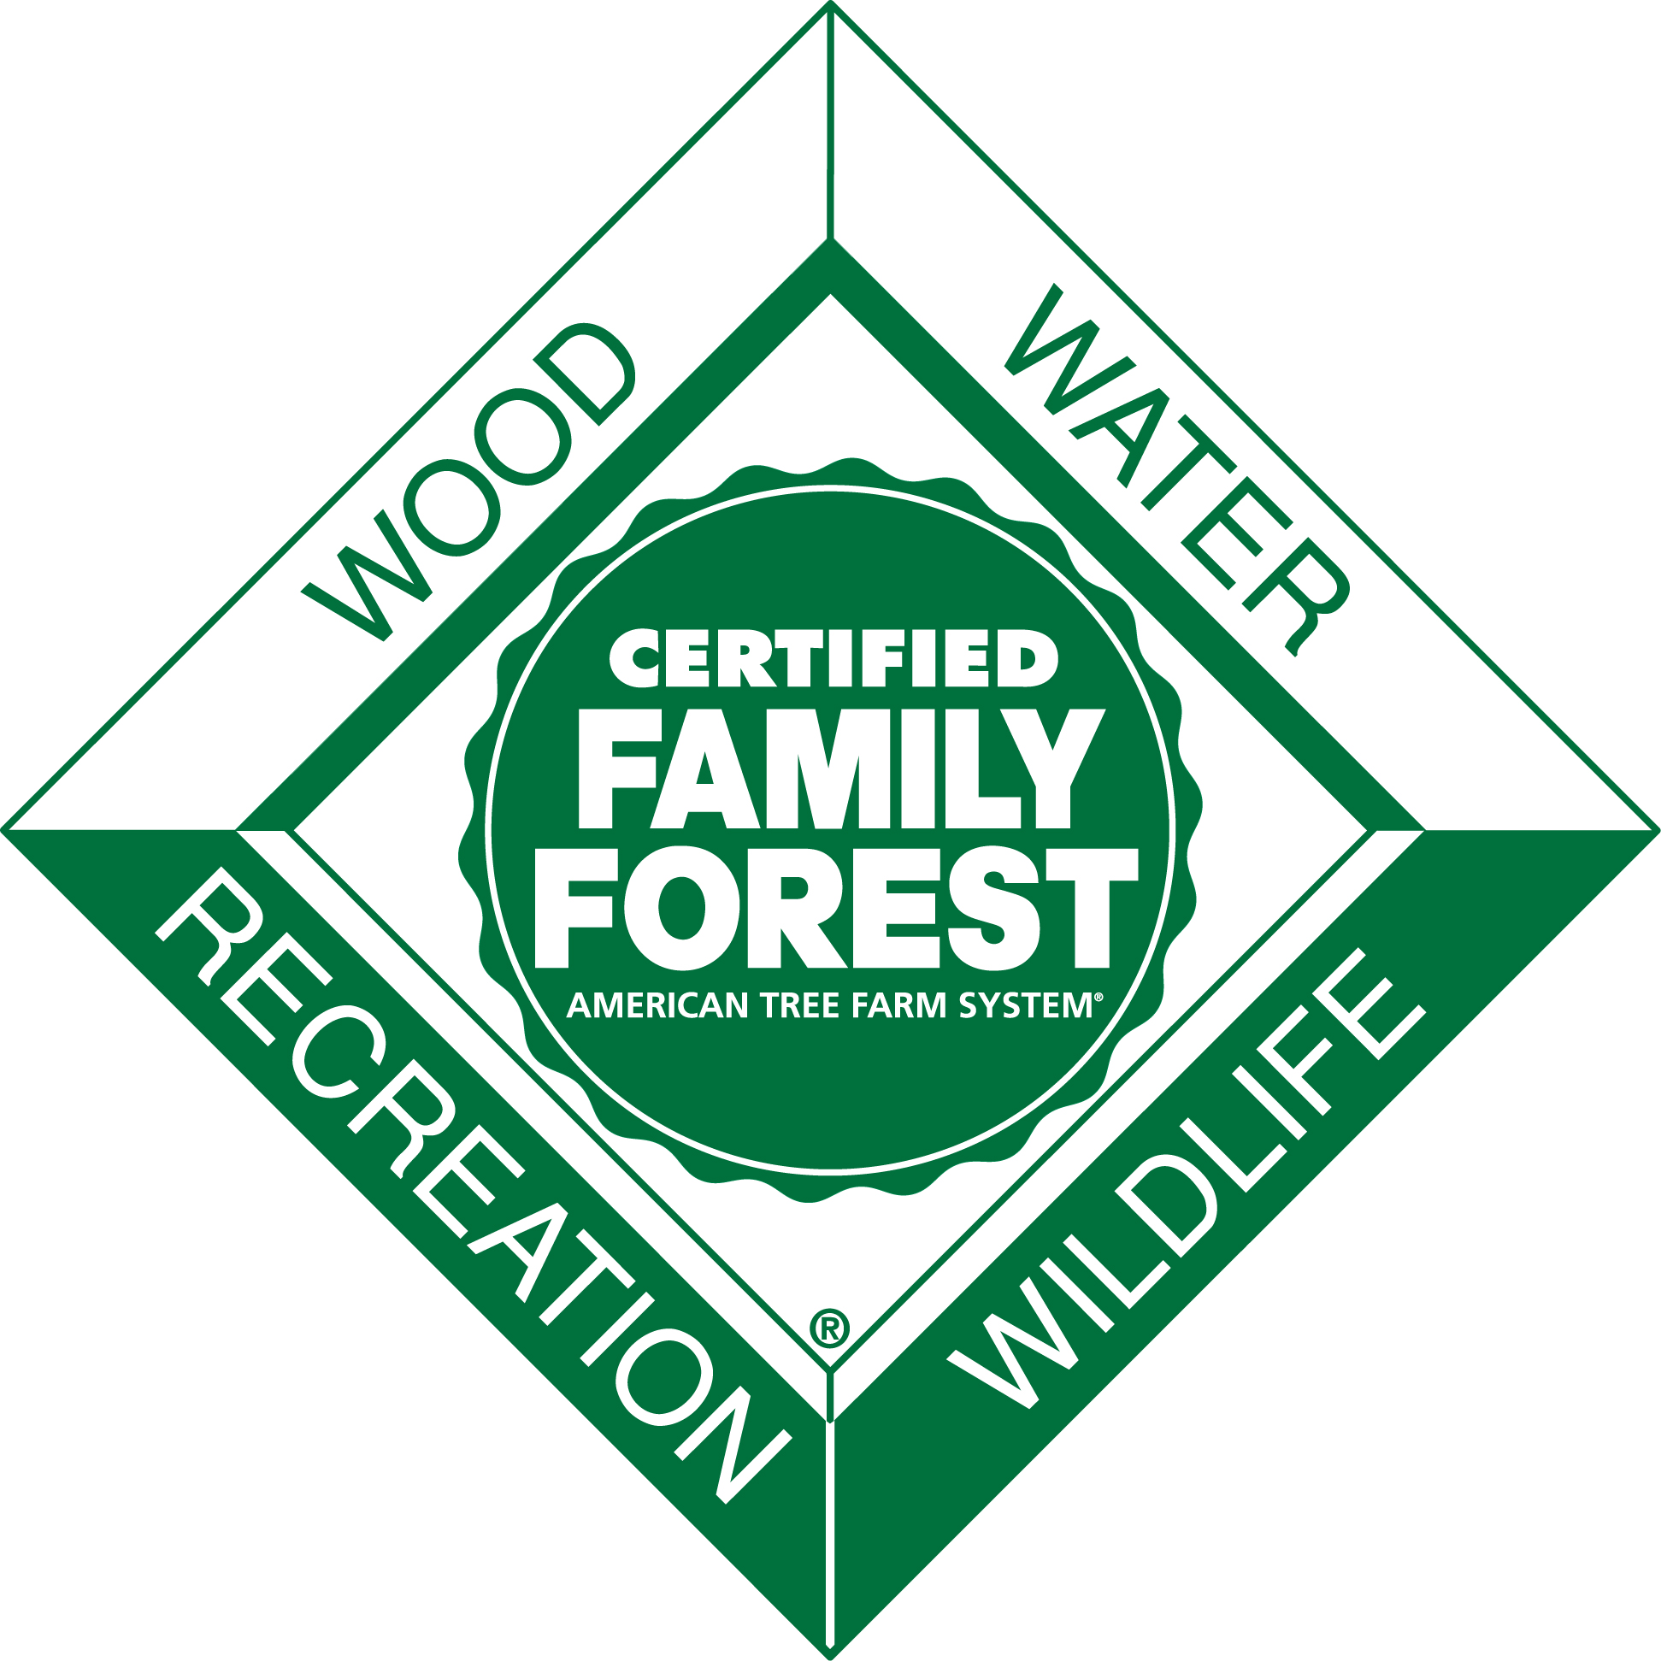
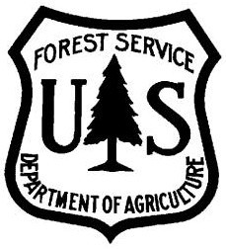


Current Condition

Total % cover by larger diameter species ( > 9 inches diameter 4.5 ft from ground > 30 ft tall)
Species % of Forested Area Age
PP Ponderosa pine
DF Douglas-fir
LPP Lodgepole pine
WL Western Larch
GF Grand fir
ES Engelmann spruce
WRC Western red cedar
WH Western hemlock
WP White pine
SAF Subalpine fir
LP Limber pine
RMJ Rocky mtn. juniper
QA Quaking aspen
CW Cottonwood
Green Ash
1.
2.
3.
4.
5.
6.
Total% cover by smaller diameter species - Poles
( 5-9 inches diameter 4.5 ft from ground < 30 ft tall)

Species % of Forested Area Age
1.
2.
3.
4.
5.
6.
Predominant stand tree structure (percent of the management unit)
Single canopy layer
Two canopy layers (Overstory + seedlings)
Three canopy (Overstory + poles, Poles + seedlings)
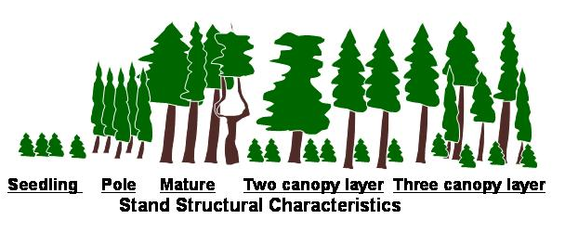
Average age of size classes
Seedlings/Saplings Poles (5-9” diameter) Large (>9” diameter)
Insect and disease symptoms noted (list species and percent of the trees showing symptoms)
Bark beetle attack Mistletoe/branch brooming Excessive pitch streaming Visible butt/root decay
Broken stems/windthrow Stem galls (western gall rust)
Stand vigor rating (use diagram below and list percent of each tree species in major crown class)
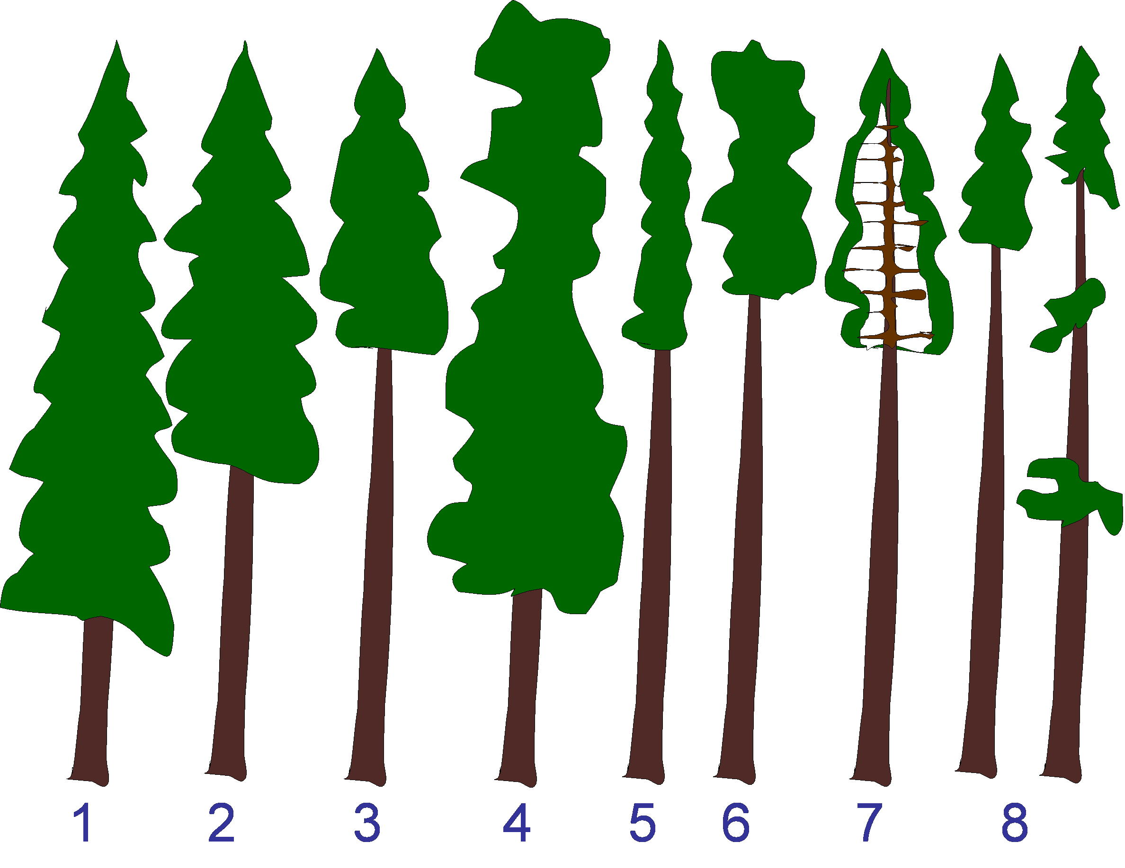

Species 1 Crown classes
Species 2 Crown classes
Species 3 Crown classes
Fire Hazard (circle High, Med, or Low in each category)
Trees with fuel ladders high > 30% med 10 – 29% low < 10%
Tree Crowns touching high > 50% med 10 – 49% low < 10%
Fine fuels (grasses taller than 2ft, > 2” deep pine needles, brush, branches) High Med Low
Large fuels (branches larger than 2 inches diameter, logs) High Med Low
Ground Fuel Continuity High – mostly touching Med – occasionally touching Low – rarely touching
Overall Wildfire risk (total circled above)
High = any two highs marked Moderate = two or more med Low = one med or less

Adjacent Management Unit/Ownership Wildfire Risk: High Moderate Low
Stream/wetland present in Management Unit
Streams Class I – length _____ Class II – length ______ Class III – length ______
# Ponds approximate sizes
Lakeshore (name of lake and distance of shoreline)
Bogs/wetland (acreage)
Soil considerations (circle all that apply) deep (>2 feet) shallow (<2 feet)
May have a mix of textures
rocky gravelly fine sandy clay well drained poorly drained

Other considerations:
Tree Density (For dense forest of mature trees choose smaller plot size that will include 5 to 10 trees)
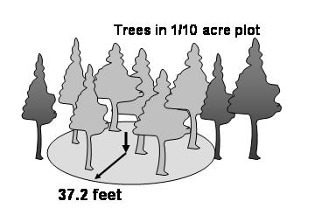
1/50 acre plot r = 16.65 ft
1/100 acre plot r = 11.8 ft
Multiplier = 10 50 100

# Large diameter trees (>9” DBH) per _______ acre plot _______ x ________ = ________ trees per acre
(multiplier)
(# of trees)
(choose plot size)

# Snags per plot per ________ acre plot ________ x ________ = ________ large snags per acre
(multiplier)
(# of trees)
(choose plot size)

# Pole sized trees (5-9” DBH) per ________ acre plot ________ x ________ = ________ poles per acre
(multiplier)
(# of trees)
(choose plot size)

# Snags per plot per ________ acre plot ________ x ________ = ________ small snags per acre
(multiplier)
(# of trees)
(choose plot size)

# Seedling/Sapling trees per 1/100 acre plot ________ x 100 = ________ seedlings per acre

% of soil covered by understory vegetation per 1/100 acre plot ________ x 100 = ________% vegetation
cover per acre
Site index – (Optional)
Species____________ Age_____ Height_______ Site index__________
Species____________ Age_____ Height_______ Site index__________
Tree growth rates
Large tree averages (based on 3 or more trees sampled per species)
Species |  |  |  | Species
DBH |  |  |  | DBH
Age |  |  |  | Age
Rings/last 1 inch |  |  |  | Rings/last 1 inch
Average DBH |  |  |  | Average DBH
Average Age |  |  |  | Average Age
Average total increment (1/2 DBH/Age) |  |  |  | Average total increment (1/2 DBH/Age)
Species |  |  |  | Species
DBH |  |  |  | DBH
Age |  |  |  | Age
Rings/last 1 inch |  |  |  | Rings/last 1 inch
Average DBH |  |  |  | Average DBH
Average Age |  |  |  | Average Age
Average total increment (1/2 DBH/Age) |  |  |  | Average total increment (1/2 DBH/Age)
Complete for each Management Unit Length of planning period ______5yr ______other
Add more pages as needed – (Additional pages at end)
Desired Future Condition - Timber MU

Desired mature tree species (% of forested area) and expected longevity (maximum age you expect
trees to reach before they die of natural causes or are harvested)
PP Ponderosa pine
DF Douglas-fir
LPP Lodgepole pine
WL Larch
GF Grand fir
ES Engelmann spruce
WRC W. Red cedar
WH Western hemlock
WP White pine
SAF Sub-alpine fir
LP Limber pine
RMJ rocky mtn. juniper
QA Aspen
CW Cottonwood Green ash

Species % of Forested Area Age
1.
2.
3.
4.
5.
6.
Desired species to naturally regenerate
Desired species to plant
Bird’s-eye view of forest (check one)
Wild Evenly Evenly spaced Variable density
stand spaced with openings spaced with openings
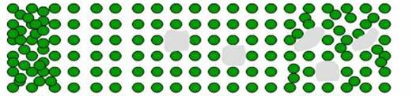
Some wildlife Maximizes growth Growth + regeneration Some growth + regeneration
+ wildlife
Desired spacing (in feet) Large (>9“DBH) (ft)
Spacing (feet) | Trees/acre
3x3 | 4,840
5x5 | 1,742
7x7 | 889
10x10 | 436
12x12 | 302
14x14 | 222
16x16 | 170
18x18 | 134
20x20 | 87
25x25 | 70
30x30 | 48
40x40 | 27

Pole (5-8”DBH) (ft) Seedling(<5”DBH)___________(ft)
Size and shape of openings
Desired structure:
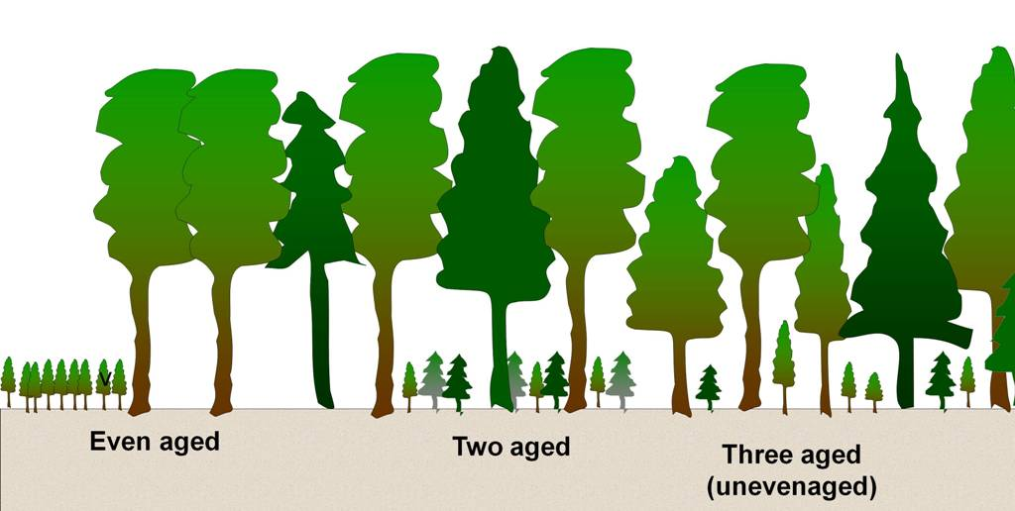
One canopy layer Two canopy layer Three canopy

