**Name:**

**Ruminant Digestive Systems Notes**

**Ruminant Digestive Systems**

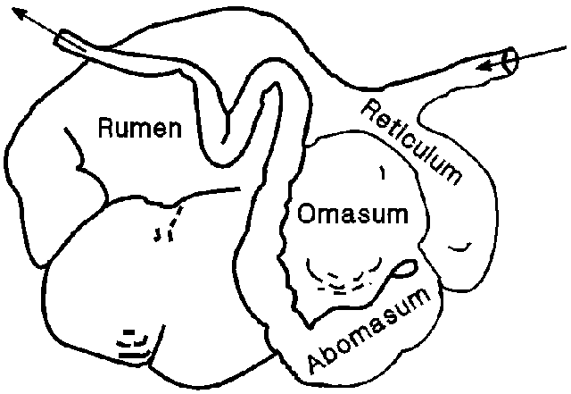

**Rumen:**

**Reticulum:**

**Omasum:**

**Abomasum:**