Salmonfly Rearing Technician
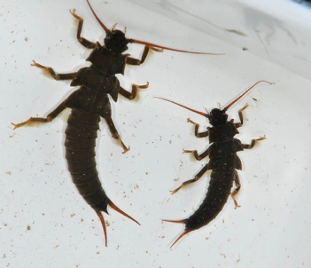
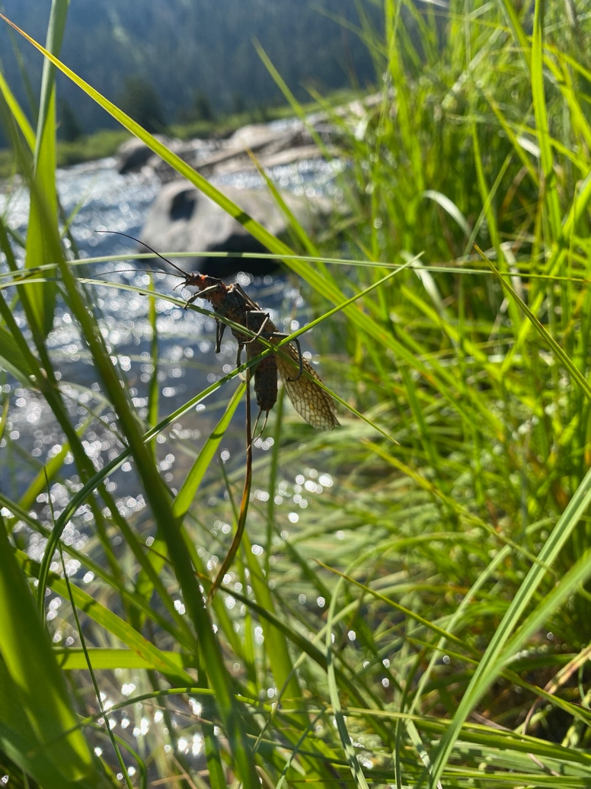
We are looking for a student to help with field collections and rearing of salmonfly nymphs in the lab on campus at MSU.

Position Dates: November 2024-March 2025 (open until filled)

Hours: 5-10 hours/week

Pay: $18/hr

Application Requirements:
Email Christine.verhille@montana.edu with:
- Your resume
- A short cover letter describing why you are interested in this position and any experience you have that you think makes you qualified for this position.

